# TASK 1:

<!DOCTYPE HTML>

<HMTL lang="en">

<head>

<meta charset="UTF-8">

<meta name="viewport" content="width=device-width, initial-scale=1.0">

<title> Huzaifa Arshad </title>

<script> </script>

<link> </link>

</head>

<body>

My name is Huzaifa Arshad. <br>

My Roll No is 21F-9323. <br>

I am a CS Student at Fast CFD.

</body>

</html>

# 

# TASK 2:

<!DOCTYPE HTML>

<HMTL lang="en">

<head>

<meta charset="UTF-8">

<meta name="viewport" content="width=device-width, initial-scale=1.0">

<title> Huzaifa Arshad </title>

<script> </script>

<link> </link>

</head>

<body>

<b>My name is Huzaifa Arshad.</b> <br>

<i>My Roll No is 21F-9323.</i> <br>

<strong>I am a CS Student at Fast CFD.</strong> <br>

<em>My name is Huzaifa Arshad.</em> <br>

<tt>My Roll No is 21F-9323.</tt> <br>

<sub>I am a <sub>CS Student</sub> at <sup>Fast CFD</sup>. <br>

</body>

</html>

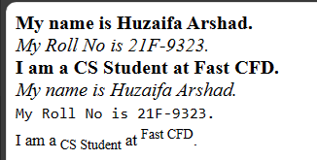

# TASK 3:

<!DOCTYPE HTML>

<HMTL lang="en">

<head>

<meta charset="UTF-8">

<meta name="viewport" content="width=device-width, initial-scale=1.0">

<title> Huzaifa Arshad </title>

<script> </script>

<link> </link>

</head>

<body>

<img src="download.jpg" width="500" height="500" alt="Alt" /><br>

<b>My name is Huzaifa Arshad.</b> <br>

<i>My Roll No is 21F-9323.</i> <br>

<strong>I am a CS Student at Fast CFD.</strong> <br>

<em>My name is Huzaifa Arshad.</em> <br>

<tt>My Roll No is 21F-9323.</tt> <br>

<sub>I am a <sub>CS Student</sub> at <sup>Fast CFD</sup>. <br>

</body>

</html>



# TASK 4:

<!DOCTYPE HTML>

<HMTL lang="en">

<head>

<meta charset="UTF-8">

<meta name="viewport" content="width=device-width, initial-scale=1.0">

<title> Huzaifa Arshad </title>

<script> </script>

<link> </link>

</head>

<body>

<a target="_blank" href="https://www.nu.edu.pk">

<img src="download.jpg" width="500" height="500" alt="Alt" />

</a>

<br>

<b>My name is Huzaifa Arshad.</b> <br>

<i>My Roll No is 21F-9323.</i> <br>

<strong>I am a CS Student at Fast CFD.</strong> <br>

<em>My name is Huzaifa Arshad.</em> <br>

<tt>My Roll No is 21F-9323.</tt> <br>

<sub>I am a <sub>CS Student</sub> at <sup>Fast CFD</sup>. <br>

</body>

</html>

# TASK 5:

<!DOCTYPE HTML>

<HMTL lang="en">

<head>

<meta charset="UTF-8">

<meta name="viewport" content="width=device-width, initial-scale=1.0">

<title> Huzaifa Arshad </title>

<script> </script>

<link> </link>

</head>

<body>

<ul>

<h1> HTML LISTS </h1>

<h2>Unordered Lists </h2>

<p>We have books on: </p>

<li> Oracle.</li>

<li> Java.</li>

<li> HTML.</li>

<li> CSS.</li>

</ul>

<ol type="1">

<h2>Ordered Lists </h2>

<p>Follow these steps: </p>

<li> Download the software.</li>

<li> Extract to a folder.</li>

<li> Double click to Execute.</li>

</ol>

</body>

</html>

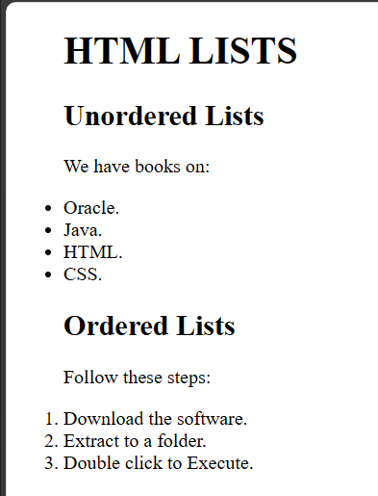

# TASK 6:

<!DOCTYPE HTML>

<HMTL lang="en">

<head>

<meta charset="UTF-8">

<meta name="viewport" content="width=device-width, initial-scale=1.0">

<title> Huzaifa Arshad </title>

</head>

<body>

<table border="1">

<tr>

<th rowspan="2">April</th>

<th>May</th>

<th>June</th>

</tr>

<tr>

<td>July</td>

<td>August</td>

</tr>

<tr>

<td>Sept</td>

<td>Oct</td>

<td>Nov</td>

</tr>

<tr>

<td>Dec</td>

<td>Jan</td>

<td>Feb</td>

</tr>

</table>

</body>

</html>

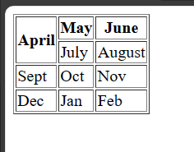

# TASK 7:

<!DOCTYPE HTML>

<HMTL lang="en">

<head>

<meta charset="UTF-8">

<meta name="viewport" content="width=device-width, initial-scale=1.0">

<title> Huzaifa Arshad </title>

</head>

<body>

<table border="1">

<tr>

<td colpan="3">2022</td>

</tr>

<tr>

<td>July</td>

<td>August</td>

<td>Sept</td>

</tr>

<tr>

<td colspan="2" rowspan="2">Oct</td>

<td>Nov</td>

</tr>

<tr>

<td>Dec</td>

</tr>

<tr>

<td>Jan</td>

<td>Feb</td>

<td>Mar</td>

</tr>

</table>

</body>

</html>

# TASK 8:

<!DOCTYPE HTML>

<HMTL lang="en">

<head>

<meta charset="UTF-8">

<meta name="viewport" content="width=device-width, initial-scale=1.0">

<title> Huzaifa Arshad </title>

</head>

<body>

<h1>Petes's Pizza Delivery </h1>

<h2>Online Order Form </h2>

<form action="/submit" >

<label> Name:</label>

<input type="text" name="name" id="1" value="" placeholder="Enter Name" required>

<input type="text" name="Tel" id="2" value="" placeholder="Enter Tel" required> <br>

<input type="text" name="Adress" id="3" value="" placeholder="Enter Address" required>

<input type="text" name="Email" id="4" value="" placeholder="Enter Email" required> <br>

<input type="password" name="pwd" id="5" value="" placeholder="Enter password" required> <br>

<input type="submit" name="submit" size="10">

</form>

</body>

</html>